| **Test Name** | Automated Operations: No Start Message if Pump Already Running |
| --- | --- |
| **Use Case Tested:** | Automated Operations |
| **Test Description:** | Verifies the business rules do not send an automated start message to the pump controller if pump is already running. |
| **Pre-conditions** | * Pump is running. * Dashboard state of pump: running. * ThingsBoard has not asked the pump to stop via manual operation. * The “switch pump on when tank level is below” field is set to 1 metres. * The current tank level is <= 1 metres. |
| **Post-conditions** | No change to System. Business rules have not sent a message to start the pump as the pump is already running. |
| **Notes:** | **This test can be run immediately after BPST001, the pre-conditions will be met.**  **This is a negative test – there will be no visible change in UI or pump controller state.** |

|  | **TEST STEP** | **EXPECTED TEST RESULTS** |
| --- | --- | --- |
|  | Use Simulator to send tank sensor message with a level of 0.9 metres. | No change to UI other than a change in the tank level indicator. |
|  | Command the pump controller to send a status message. | No change to system. |

|  |  |  |  |  |  |
| --- | --- | --- | --- | --- | --- |
| **Test Data Table** | | | | | |
|  | **1** | **2** | **3** | **4** | **5** |
| [Data field 1] | [data set 1 input value for field 1] |  |  |  |  |
| [Data field 2] | [data set 1 input value for field 2] |  |  |  |  |
| [Data field 3] | [data set 1 input value for field 3] |  |  |  |  |

**Results**

26/08/2020

Passed. Sent a couple of tank level messages, last one was 0.7m.

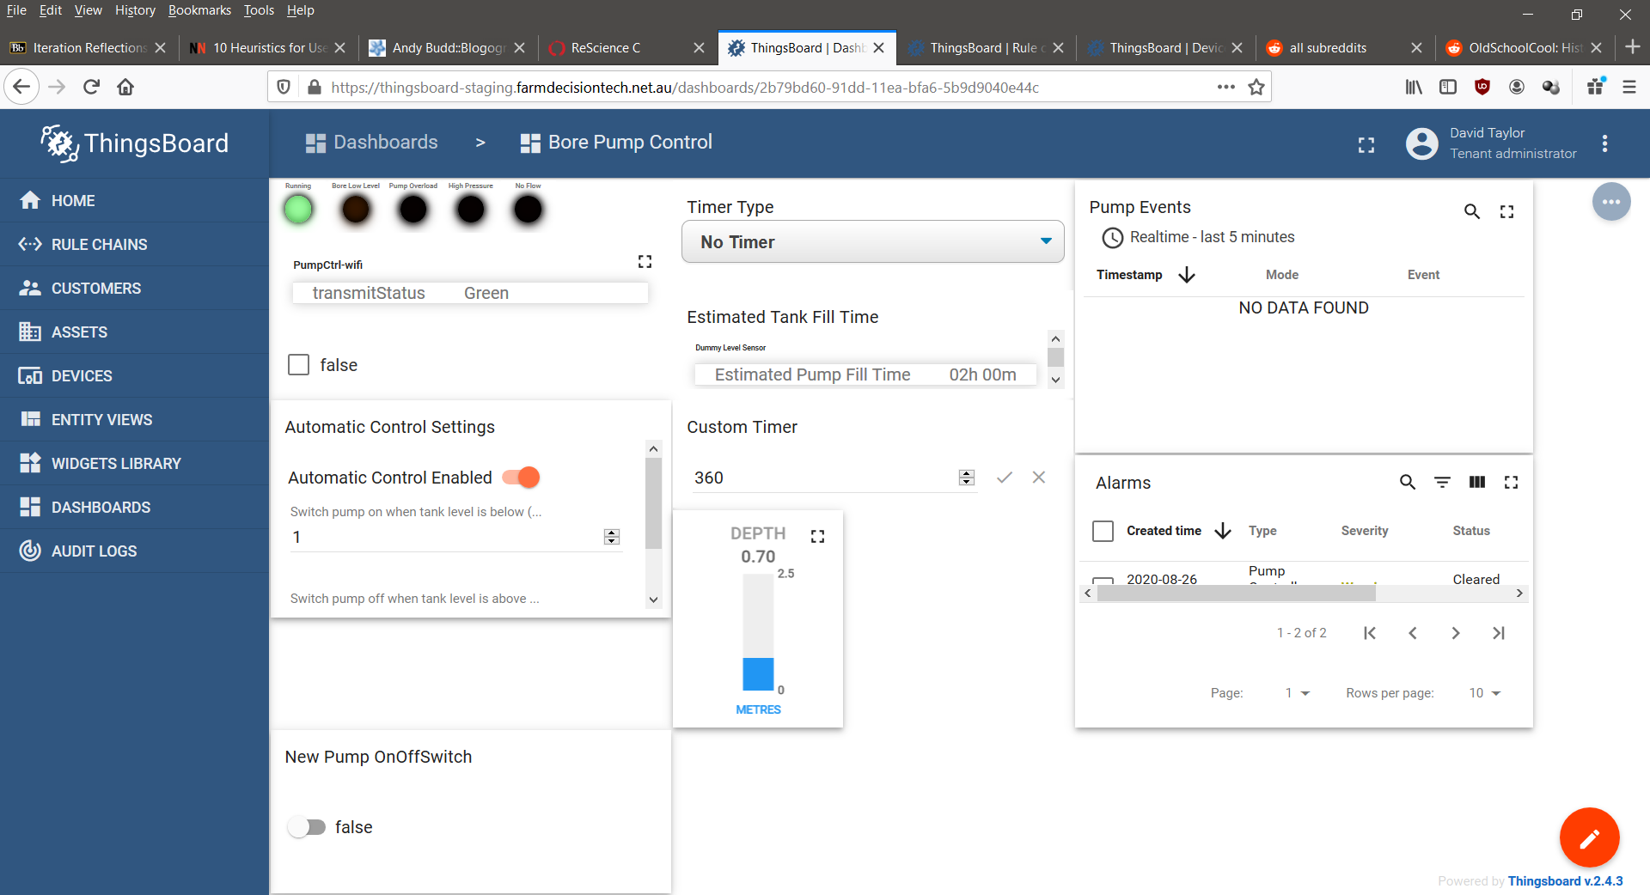

/

02/09/2020

Passed. Received tank level messages had no effect on the status of the dashboard

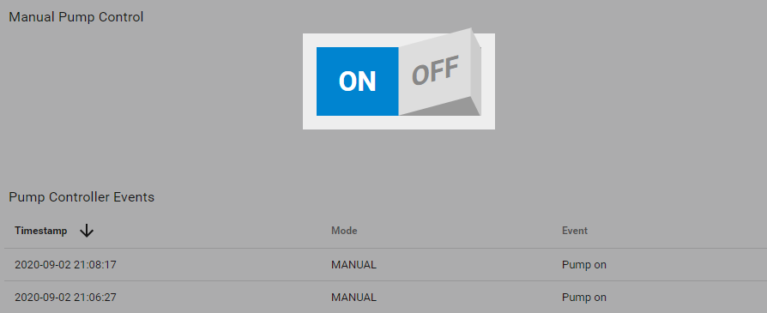

9/9/2020 – On site test at OAI.

Success.

10:25:53.825 -> Send operator requested status message.

10:25:53.825 -> LoRaWAN will encode and send this message: {'pumpRunning':1,'boreLowLevel':0,'softStartFail':0,'pumpOverload':0,'controllerRestart':0,'highPressure':0,'noFlow':0}

10:25:53.825 -> Sending status byte: 01

10:25:55.961 -> EV_TXCOMPLETE (includes waiting for RX windows)

